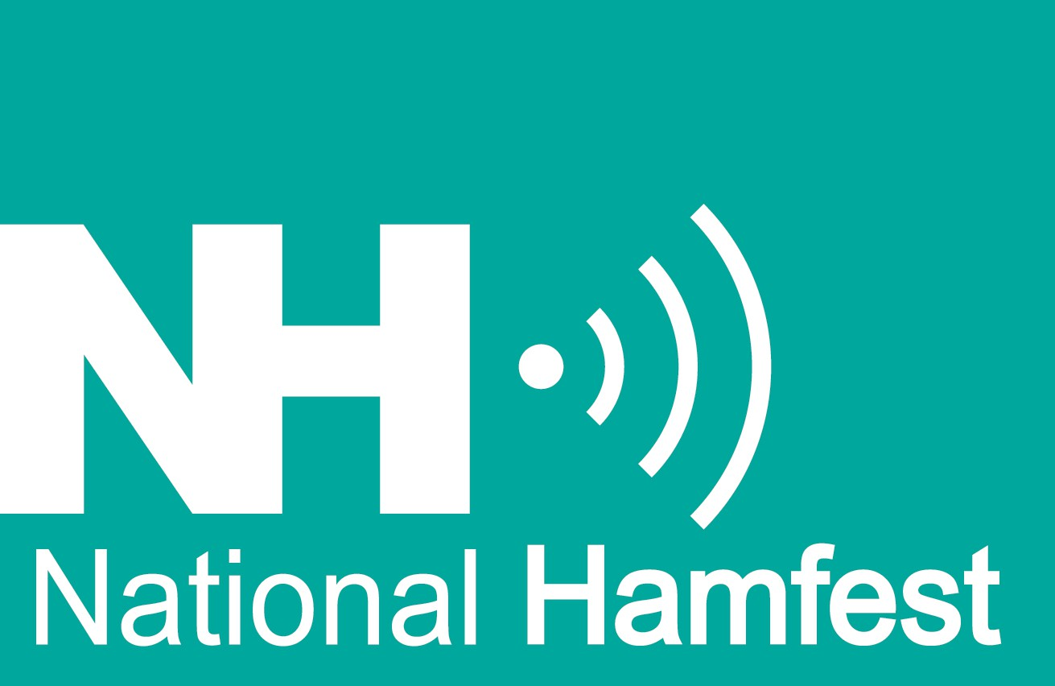
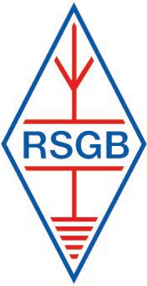
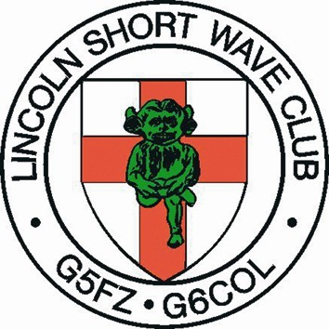
National Hamfest 2026

Club Booking Form
Your Club Name:
Contact Name: Address:
Tel:
Mob:
Email:

The Commercial rates are discounted for Clubs and Societies. See the list below to make a booking.
Please note: These rates are for non-commercial activity only i.e. demonstration and or fundraising – only sales of donated items and Club badged merchandise for Club funds are permitted.
Please Accept the following booking for a Club or Societies Stand at the ‘National Hamfest 2026. To be held on Friday September 25th and Saturday September 26th 2026 at the Newark and Notts. Showground, Lincoln Road, Winthorpe, Nr. Newark, Nottinghamshire, NG24 2NY

Attendance (please tick) Friday September 25th [ ] Saturday September 26th. 2026 [ ]

Item | Price Early Bird | Description | Tick | Amount to Pay
Small Stand | £45.00 (£40) | For two days 2m x 2m Inc 1 table 2 trade passes
 | £30.00 (£25) | For one day 2m x 2m Inc 1 table 2 trade passes
Double Stand | £90.00 (£85) | For two days 4m x 2m Inc 2 tables 3 trade passes
 | £60.00 (£55) | For one day 4m x 2m Inc 2 tables 3 trade passes
Extra Passes | £12.00 | For one person a two-day pass
Extra Tables | £8.00 each  (£6.00) | used as ‘backing’ tables only (2 max) add  [ ] }
Power | Included | Shared Power per block, no exclusive use
Total Amount I am paying |  |  |  | £
NB: Early Bird Discount only applies to the 31st July 2025, 1st August onward full Price.
I have read, understand and accept the ‘National Hamfest’ Terms and Conditions; (this form).
Signed:
Print Name:
Date:

Payments. By bank transfer National Hamfest (Lincoln) Ltd A/c 52955079 sort 60-13-15 ref.. Club name.
Then please email your completed form to Chris@Danby-online.co.uk
By Cheque, make payable to National Hamfest (Lincoln) Ltd and post with completed form to
Ian Shepherd 12 Watsons Lane, Harby, Melton Mowbray, LE14 4DD synapse@btinternet.com
For further booking information contact Chris Danby, email: Chris@Danby-online.co.uk
Telephone during office hours only please:- 07889 325774
Important: Please provide a contact email address as essential show information will be emailed to you. Your e mail address will not be used for any other purpose and certainly not passed to any other organisation.

Regular updated Information is available at www.nationalhamfest.org.uk

If you have problems downloading this form we can supply a ‘hard’ copy via the post

